Request to create storage mapping report in WMS,

The objective of application is to mapped temperature storage required products against physical putaway locations.

To reduce manual mapping process and increase frequency of mapping thru system to detected if any products are putaway to wrong temperature storage locations, on time correction if is error found.

Bin Utilization report -

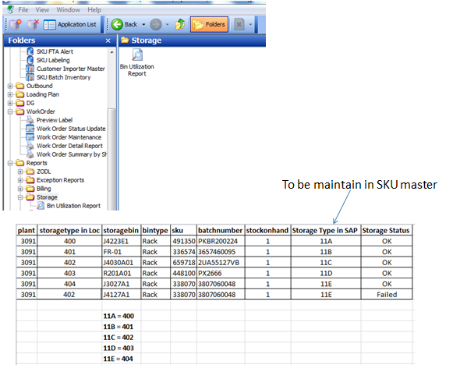

Location Storage type mapped to SKU Storage type

|  |  |
| --- | --- |
| Location Storage type | SKU Storage type |
| 400 | 11A |
| 401 | 11B |
| 402 | 11C |
| 403 | 11D |
| 404 | 11E |

**WMS Changes: [2016.02.26]**

1. **WMS Codelkup**: Listname = STORTYPE

Long = SKU Storage type

|  |  |  |  |  |
| --- | --- | --- | --- | --- |
| Listname | Code | Description | Short  (Storage zone) | Long  (SKU Storage type) |
| STORTYPE | 400 | Ambient | NAC | 11A |
| STORTYPE | 401 | Freezer | F | 11B |
| STORTYPE | 402 | AirCon | NAC | 11C |
| STORTYPE | 403 | Reefer | R | 11D |
| STORTYPE | 404 | Posiflush | AC | 11E |

1. **SKU** – add storage type field.

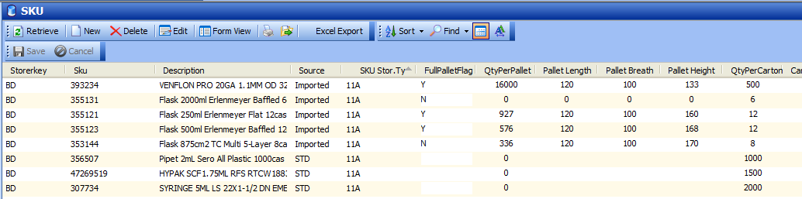

1. **Storage Bin Utilization report :**

**Added:**

Stor Type in SAP (SKU) – storage type mapping in SKU master

Storage status = “OK” when the StorTYpe of Location matched with SKU Stor.type.

= “Failed” when both the Loc and SKU Stor.Type do not match.

